CALERA POLICE DEPT.
APPLICATION

Return completed application to:
CALERA POLICE DEPT.
112 W. MAIN ST.
CALERA OK, 74730

In filling out the application, you must complete ALL questions. Do not leave any blanks. If the question does not apply then write N/A in the blank. Any applications which are not completed, legible, or with questions left blank will be deemed as unfinished and will NOT be processed.
DATE:
THE APPLICANT MUST PROVIDE THE FOLLOWING

- COPY OF DRIVER LICENSE
- COPY OF HIGH SCHOOL DIPLOMA OR G.E.D.
- COPY OF SOCIAL SECURITY CARD
IF APPLICABLE:
- FORMER MILITARY - COPY OF CURRENT DD214
- NATIVE AMERICAN - COPY OF CDIB CARD
- SDA LICENSE – COPY OF LICENSE

# | Test Component | Distance to Component (Feet) | Distance of Component (Feet) | Total Distance (Feet)
1 | Run | 0 | 332.3 | 332.3
2 | Step and Slide to Left | 0 | 30.0 | 30.0
3 | Diagonal Shuffle to Rear and Right | 0 | 32.6 | 32.6
4 | Step and Slide to Right | 0 | 30.0 | 30.0
5 | Diagonal Shuffle to Rear and Left | 0 | 32.6 | 32.6
6 | Crawl on Stomach | 24.0 | 20.0 | 44.0
7 | Bear Crawl | 55.8 | 20.0 | 75.8
8 | Obstacle Dodge (10 cones, 8 FT apart, and offset by 2 FT) | 51.0 | 62.3 | 113.3
9 | Weight Drag (APPROX. 95 lbs) | 76.8 | 20.0 | 96.8
 |  |  |  | 787.4
CLEET OBSTACLE COURSE (TIMED)
Candidates must successfully complete all components in 2 minutes and 22 seconds or less.

1. Run: A test monitor will give the candidate verbal instructions to “GO” and the candidate will begin the run around the gym (approximately 332 total feet).

2. Step and Slide to Left: At the conclusion of the run, the candidate will remain facing the wall directly in front of him/her, and then step and slide sideways (shuffle) to their left into the obstacle course, and continue stepping and sliding sideways to their left for a distance of about 30 feet. Candidates should not cross their legs as they shuffle to the left to prevent tripping themselves, and they should shuffle all the way until their foot touches the line about 30 feet away.

3. Diagonal Shuffle to Rear and Right: After stepping and sliding 30 feet to their left, and while still facing the wall directly in front of them, candidates will step and slide backwards (rear diagonal shuffle) to their right and behind them (at an approximately 35 degree angle) for approximately 33 feet. They will continue to face the wall while doing this. Candidates should not cross their legs as they shuffle backwards and to the right to prevent tripping themselves, and they should shuffle all the way until their foot touches the line about 33 feet away. Once their foot touches the line, they will turn around and face the opposite wall before performing the next component.

4. Step and Slide to Right: After completing the backwards diagonal shuffle, and after turning around so that the candidate is facing the wall opposite of the one they were facing in the previous two components, the candidate will step and slide sideways (shuffle) to their right for a distance of about 30 feet. Candidates should not cross their legs as they shuffle to the right to prevent tripping themselves, and they should shuffle all the way until their foot touches the line about 30 feet away.

5. Diagonal Shuffle to Rear and Left: After stepping and sliding 30 feet to their right, and while still facing the wall directly in front of them, candidates will step and slide backwards (front diagonal shuffle) to their left and behind them (at an approximately 35 degree angle) for approximately 33 feet. They will continue to face the wall while doing this. Candidates should not cross their legs as they shuffle backwards and to the left to prevent tripping themselves, and they should shuffle all the way until their foot touches the line about 33 feet away. Once their foot touches the line, they move on to the next component.
6. Crawl on Stomach: After the rear diagonal shuffle, candidates will get on their stomachs and crawl a distance of approximately 20 feet using their elbows and forearms only, and with their legs bent so that their feet are up in the air. Candidates will crawl with their elbows and forearms, and without the use of their legs (simulating legs that are not functioning), until they are able to touch the floor with their hand just beyond the end of the floor mat. After crawling for about 20 feet and touching the floor at the end of the mat, candidates will get up safely and proceed to the next event. Candidates should take care to get up safely, orient themselves and then proceed to the next component.

7. Bear Crawl: Candidates will get down on their hands and feet only with their hands behind the line, and then crawl a distance of approximately 20 feet using their hands and feet only. Candidates must re-attempt this component while the time is running if their knees, elbows, or other parts of their body touch the floor during the component. Candidates must bear crawl the distance of 20 feet all the way until both of their feet are across the line. After bear crawling for about 20 feet, candidates will get up safely and proceed to the next event. Candidates should take care to get up safely, orient themselves and then proceed to the next component.

8. Obstacle Dodge: The candidate will maneuver, in a zig-zag manner, around obstacles (which are traffic cones positioned on the ground).

9. Weight Drag: (approximately 95 lbs): The candidate will drag a weight completely past a line
20 feet away. Timing of the test stops when the entire weight passes over the line.

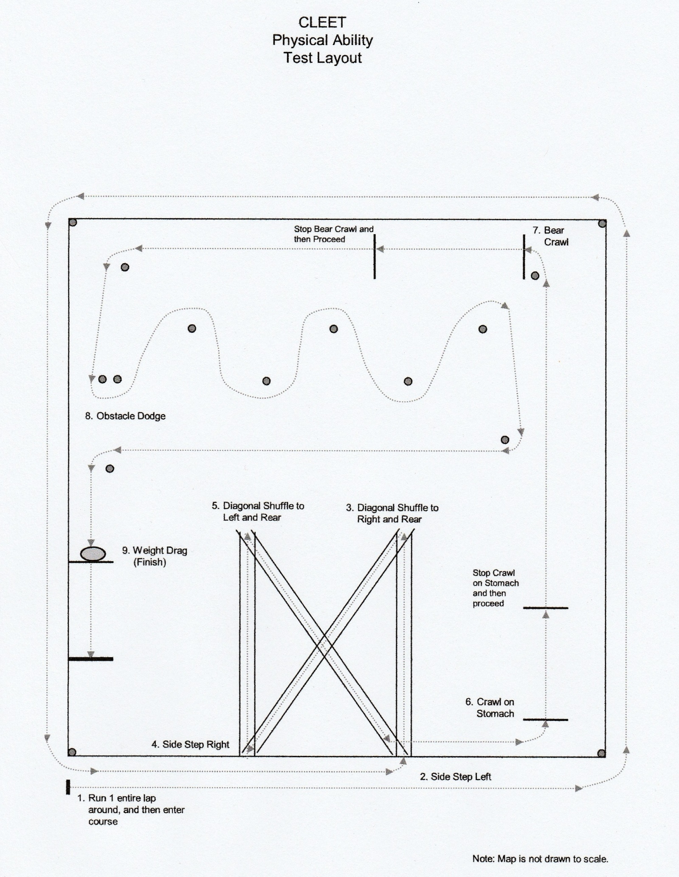

CALERA POLICE DEPARTMENT APLLICATION
We consider all applicants for all positions without regard race, color, religion, creed, gender, national origin, age, disability, marital, veteran status, sexual orientation, or any other legally protected status.

( PLEASE PRINT )

Position applied for: (Check all that apply) Reserve Part-Time Full Time

How did you hear about us: Ad Friend Walk in Employment Agency Relative

Other (Explain) _______________________________________________

Last Name First Name Middle Name Suffix

Address City State Zip Code

( ) ( ) - - / /
Home/Cell Phone Number Other contact Number Social Security Number Date of Birth

/ / Yes No Not Sure
Driver License Number State Expiration Have you ever been suspended or revoked

If you are 21 can you provide Yes ______ No ______ If Yes, Give Date ____/_____/______
proof of eligibility to work?

Have you ever filed an Yes ______ No ______ If Yes, Give Date ____/_____/______
application with us before?

Have you ever been Yes ______ No ______ If Yes, Give Date ____/_____/______
employed with us before?

Are you currently employed? Yes ______ No ______ If Yes, Where ___________________

May we contact you current Yes ______ No ______ If Yes, Number (____)_____/______
employer?

WE ARE AN EQUAL OPPORTUNITY EMPLOYER

Are you prevented from lawfully becoming employed in this Yes No

country because of Visa or Immigration Status?
(Proof of Citizenship or Immigration Status will be required upon employment)

On what date would you be available for work? Date ____/_____/______

Some reserve schools and police academies are not in this
area and you may have to travel at your own expense. Yes No

Will this be an issue?

Do you Gamble: Yes If so explain: _____________________________________________

No _____________________________________________

Do you use Yes If so explain: _____________________________________________

Alcoholic Beverages: No _____________________________________________

Do you belong to or
frequently attend any Yes If so explain: _____________________________________________

bars or private clubs: No _____________________________________________

Have you ever used Yes If so explain: _____________________________________________

Marihuana: No _____________________________________________

Have you ever used Yes If so explain: _____________________________________________

Steroids: No _____________________________________________

Have you ever used Yes If so explain: _____________________________________________

any other illegal No _____________________________________________

substance:

Have you applied to Yes If so explain: _____________________________________________

any other agencies: No _____________________________________________

Have you ever been

dismissed or asked to Yes If so explain: _____________________________________________
resign from any position: No _____________________________________________

Have you ever been
physically limited Yes If so explain: _____________________________________________

on a job: No _____________________________________________

Have you ever been Yes If so explain: _____________________________________________

hospitalized: No _____________________________________________

Have you ever been
in the care of a Yes If so explain: _____________________________________________

psychiatrist: No _____________________________________________

In the past three years
have you been regularly
taking medication: Yes If so explain: _____________________________________________

(Includes Prescription) No _____________________________________________

Have you discussed
this line of work with Yes If so explain: _____________________________________________

your friends and family: No _____________________________________________

Have you ever been Yes If so explain: _____________________________________________

fingerprinted: No _____________________________________________

Have you ever been detained, arrested, or investigated by any Law Enforcement Agency:
Date | Charge | Location | Agency | Disposition

List all traffic citations or Arrest (Excluding Parking):
Date | Charge | Location | Agency | Disposition

List three references (Not relatives)
Name | Address | Phone Number | Years Known

List five social acquaintances
Name | Address | Phone Number | Years Known

EDUCATION

HIGH SCHOOL

GED

COLLEGE # OF HOURS _______ ASSOCIATES DEGREE

BACHELORS DEGREE
MASTERS DEGREE

DOCTORATE DEGREE

HIGH SCHOOL NAME _________________________ CITY _____________ STATE_________

HIGH SCHOOL NAME _________________________ CITY _____________ STATE_________

GED NAME _________________________ CITY _____________ STATE_________

COLLEGE NAME _________________________ CITY _____________ STATE_________

CREDITS EARNED ______________ MAJOR_____________________________

COLLEGE NAME _________________________ CITY _____________ STATE_________

CREDITS EARNED ______________ MAJOR_____________________________

POLICE/MILITARY EXPERIENCE

Police Experience: Yes No Part Time Full Time Reserve Military

Department: __________________________________ Length at Department: ______________________

Department: __________________________________ Length at Department: ______________________

Military Experience: (Submit current DD214 with this application)
Yes No Honorable Discharge: Yes No N/A

Describe any job related training received in the military: ________________________________________________________________________________________________________________________________________________________________________________________________________________________________________________________________________________________________________________________________________________________________________

Describe any specialized training, apprenticeship, skills, and extra-curricular activities: ________________________________________________________________________________________________________________________________________________________________________________________________________________________________________________________________________________________________________________________________________________________________________

FOREIGN LANGUAGE

Language: ___________ Speak Fluent

Read Good

Write Fair

Language: ____________ Speak Fluent
Read Good

Write Fair

EMPLOYMENT

EMPLOYER | ADDRESS | PHONE | SUPERVISOR | START | END
Start with your present or most recent employment. Include any volunteer activities. You may exclude organizations which indicate race, color, religion, gender, national origin, disabilities, or any other protected status.

State any additional information that you feel may be helpful to us in considering your application:
__________________________________________________________________________________________________________________________________________________________________________________________________________________________________________________________________________________________________________________________________________________________________________________________________________________________________________________________________________________________________________________________________________________________________________________________________________________________________________________________________________________________________________________________________________________________________________________________________________________________________________________________________________________________________________________________________________________________________________________________________________________________________________________________________________________________________________________________________________________________________________________________________________________
NOTE TO APPLICANTS: DO NOT ANSWER THIS QUESTION UNLESS YOU HAVE BEEN INFORMED ABOUT THE REQUIREMTNS OF THE JOB FOR WHICH YOU ARE APPLYING. ARE YOU CAPABLE OF PERFORMING IN A REASNABLE MANNER, WITH OR WITHOUT ACCOMMADATION, THE ACTIVITIED INVOLVED IN THE JOB OR OCCUPATION FOR WHICH YOU HAVE APPLIED: A DESCRIPTION OF THE ACTIVITIES INVOLVED IN SUCH A JOB OR OCCUPATION IS ATTACHED.

YES NO

I certify that the answers given herein are true and complete to the best of my knowledge. I authorize investigation of all statements contained in the application for employment shall be considered active for a period of time not to exceed 45 days. Any applicant wishing to be considered for employment beyond this time period should inquire as to whether or not applications are being accepted at this time. I hereby understand and acknowledge that, unless otherwise defined by applicable law, any employment relationship with this organization is of an “at will” employment relationship and may not be changed by any written document or by conduct unless such change is specifically acknowledged in writing by an authorized executive of this organization. In the event of employment I understand that false or misleading information given in my application or interview(s) may result in discharge. I understand also that I am required to abide by all rules and regulations of the employer.

_____________________________ _____/_____/______
Signature of Applicant Date

Official Waiver of Liability and Release of All Claims
Physical Test for Safe Participation

Instructions: Please read this form carefully and completely. Then sign and date the form at the bottom.

I declare and represent that I received a sample written description of the Physical Test for Safe Participation Study Guide and am aware of what this test entails. I further declare and represent that I am now in good health, that I am familiar with and understand the nature of the Physical Test for Safe Participation, that I am physically and medically fit to participate in the tests, and that my personal attire is safe and fit for participation in the test. I personally assume any and all risks of injury with respect to all matters pertaining to my participation in the test, including death, damage, or loss which I may sustain as a result of participating in any activities associated with the test.
I hereby consent and agree to all of the following terms and conditions.

Acknowledgment of Risk As a participant in the Physical Test for Safe Participation, I recognize and acknowledge that there are certain risks of physical injury. I agree to assume the full risk of any injury, including death, damage or loss which I may sustain as a result of participating in any and all activities connected with or associated with the test.
Waiver of Liability and Release of All Claims I do hereby for myself, heirs, executors and administrators, and other parties claiming under or through me, fully waive, relinquish, release, and forever quit-claim and discharge CLEET and all its elected officials, trainers, officers, agents, employees, servants, monitors, and examiners from any and all liability, claims, demands, actions, and causes of action whatsoever arising out of or related in any way to any loss, damage, or injury (including death) that may be sustained by me while participating in the Physical Test for Safe Participation, or upon the premises where the test is begin conducted, whether the loss, damage, injury, or death results from the negligence of CLEET or its elected officials, trainers, officers, agents, employees, servants, monitors, or examiners, or is otherwise caused.
Indemnity and Defense I do hereby agree, for myself, heirs, executors, and administrators, and other parties claiming under or through me, to indemnify and hold harmless and defend CLEET and its elected officials, trainers, officers, agents, employees, servants, monitors, and examiners from any and all claims, suits or demands, actions, or causes of action whatsoever arising out of or related in any way to loss, damage, or injury (including death) that may be sustained by me while participating in the Physical Test for Safe Participation, or upon the premises where the test is being conducted.
Other I understand that the test administration staff may remove me from the test if they believe I might endanger myself or be an endangerment to others.
I hereby certify and declare that I have read all of the foregoing terms, conditions, and declarations, and I fully understand and agree to them.

Signature Date

Printed Name

